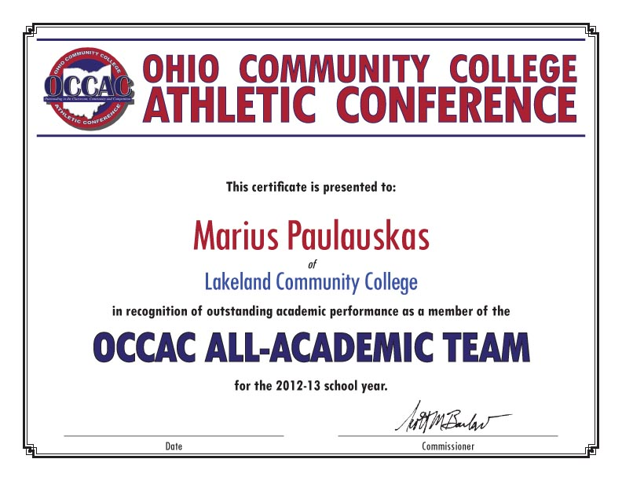
OCCAC PLAYER OF THE WEEK WEEK
in the sport of [insert sport]
in recognition of outstanding athletic performance as the
of
college
name
Date

